Data Collected during the Capstone Project and its Analysis

**Requirement Analysis Stage**

During Requirement Elicitation, data was taken from the potential users of the Ashesi Tutor Management System for analysis. The following are the questions sent and results obtained:

Ashesi Students (Questions and Results)

Ashesi Faculty (Questions and Results)

Departmental Coordinators (Questions and Results)

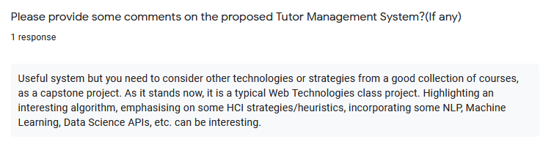

Analysis of the above data

All Ashesi students and faculty who filled the form expressed the urgent need for an Ashesi Tutor Management System. Two Departmental Coordinators also expressed that this system would be relevant for their department and help to curb the problem of lack of understanding in courses. 87%, representing more than half of Ashesi Students who filled the form expressed the fact that they truly face difficulty in understanding some class concepts taught in class whiles 53.3% represent the option that they often find it difficulty to find tutors for a course. All Ashesi Faculties who filled the form also express that they are sometimes approached by students for course help. Therefore the above pieces of evidence from the data testified that the lack of understanding of concepts by students was indeed a problem hence the development of an Ashesi Tutor Management System to address this need was beneficial.

**User Testing Stage**

After development of the application, the potential users tested the application to witness its functionalities, quality attributes, objectives, and relevance of the application. A survey was then carried out to enable Ashesi Students after going through the process of testing, to provide feedback on what they think of this application. Below was the data taken from users:

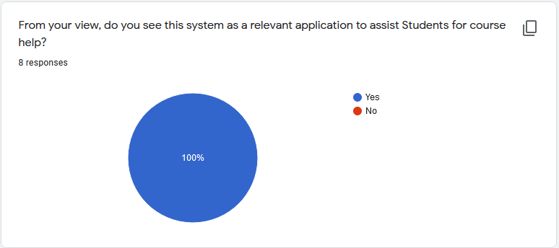

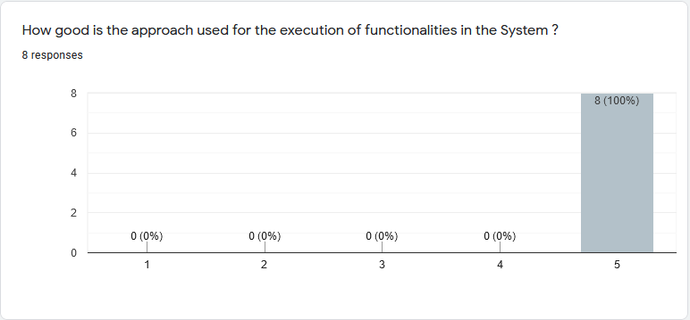

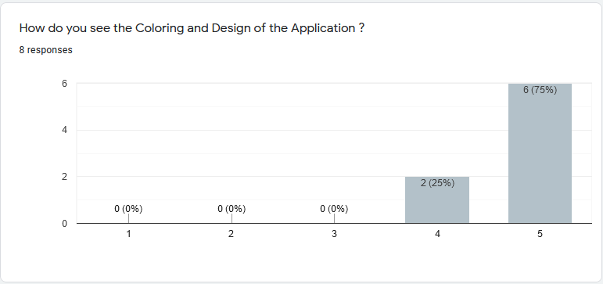

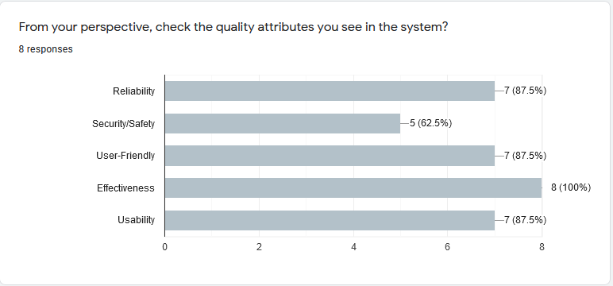

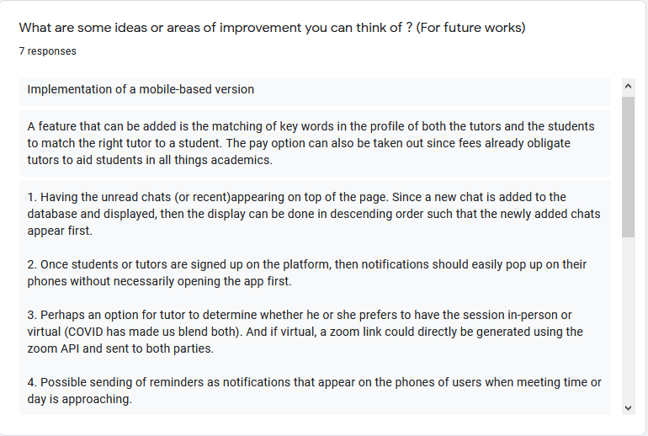

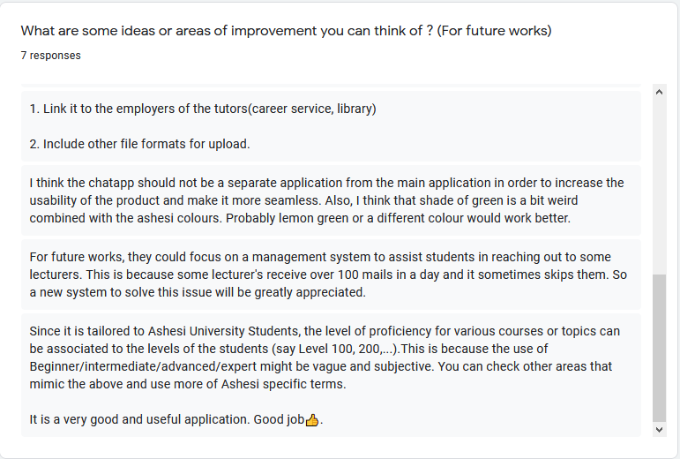

Analysis of the above data

All Ashesi students who tested the application and filled the survey, indicated that the currently implemented system is relevant and can help students to achieve their objective of getting help for courses. They also indicated that the approach used within the application in the achievement of functionalities was excellent with 75% representing those who expressed good remarks about the coloring and designing of the application. For the non-functional requirements, all of them indicated that indeed the system is effective whiles 87.5% represents those who expressed that the application is reliable, user-friendly, and usable. 62.5% represents the opinion of those who said that the application achieved security and safety. This analysis highlighted how good and remarkable the Ashesi Tutor Management System is because Ashesi students have proven that this system can help to assist them when they face course difficulties.